Add the below dependencies

<!--ReportNg-->

<dependency>

<groupId>org.uncommons</groupId>

<artifactId>reportng</artifactId>

<version>1.1.4</version>

<scope>test</scope>

</dependency>

<!--Velocity-dep-1.4-->

<dependency>

<groupId>velocity</groupId>

<artifactId>velocity-dep</artifactId>

<version>1.4</version>

</dependency>

<!--Guice 3.0-->

<dependency>

<groupId>com.google.inject</groupId>

<artifactId>guice</artifactId>

<version>3.0</version>

</dependency>

Goto>project>rightclick>update maven

Goto>project>rightclick>properties>testng

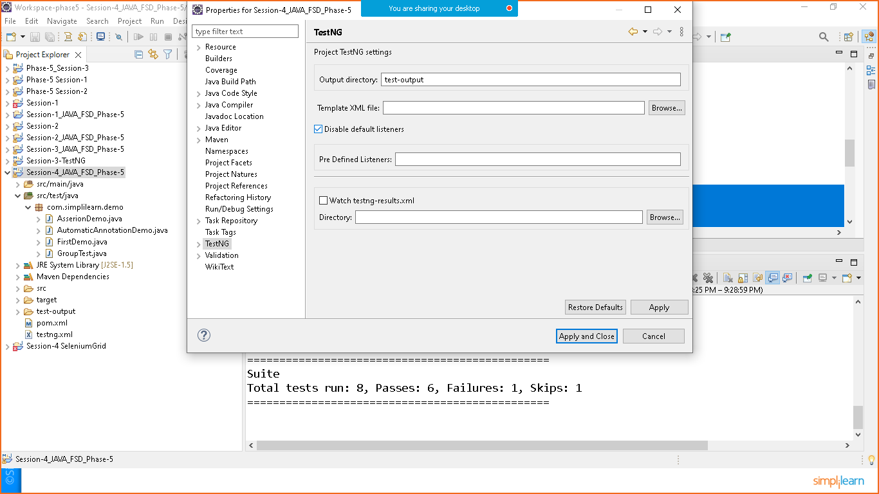

Click on disble default listener

Goto > testng.xml

<suite name=*"Suite"*>

<listeners>

<listener class-name=*"org.uncommons.reportng.HTMLReporter"*></listener>

<listener class-name=*"org.uncommons.reportng.JUnitXMLReporter"*></listener>

</listeners>

</suite> <!-- Suite -->

Right click on testng.xml file and run as testng suit

Once the suit will excecute all the test reports will be generated automatically

Right click on project > refresh

You will see test-output folder with sub folder html

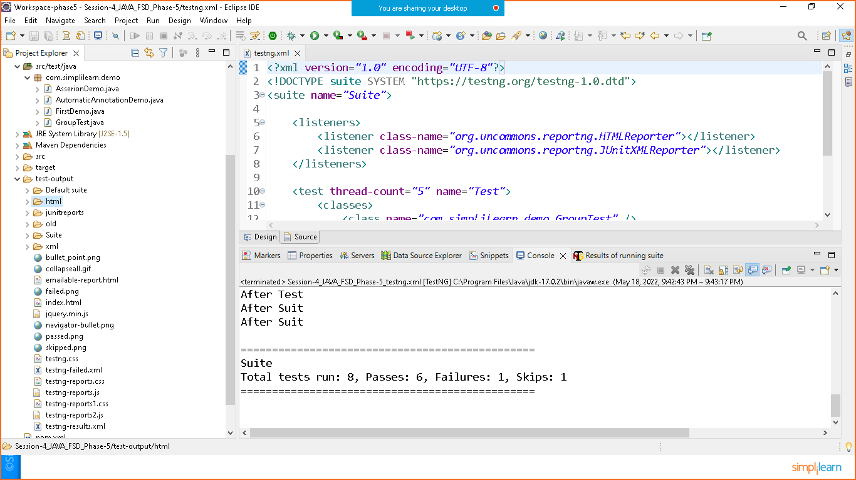

Now open html folder and open index.html with browser

